Multivariate bias correction improves inter-station dependence relative to QDM in multi-site daily precipitation across a coastal gauge network in Thailand
Surasit Punyawansiri^{1,*}
¹Office of Water Management and Hydrology, Royal Irrigation Department, Dusit, Bangkok, Thailand
*Corresponding author: Surasit.pum@thaimooc.ac.th
Article type: Research article

Abstract
Bias correction of climate-model precipitation is usually evaluated station by station, although distributed hydrological applications also require realistic dependence among gauges. We compared N-dimensional multivariate bias correction (MBCn), quantile delta mapping (QDM), and uncorrected output for 12 daily rain gauges on the western Gulf of Thailand coast and seven CMIP6 models. Methods were calibrated on 1981-2000 and evaluated independently on 2001-2014. Because the final MBCn step reinstates QDM values at each gauge, both methods produced identical results for six marginal diagnostics across all 84 gauge-model combinations. MBCn improved all six dependence diagnostics. Relative to QDM, it reduced energy distance from 0.852 to 0.571 and Spearman correlation-matrix RMSE from 0.286 to 0.187; all seven models improved on every diagnostic (one-sided exact Wilcoxon p = 0.0078; rank-biserial effect size = 1.00). Most dependence gains occurred within 10-15 iterations, results were insensitive to random seed, and projected wet-day quantile changes remained comparable to QDM. QDM is therefore sufficient when only station-level distributions are required, whereas MBCn is better supported when spatial dependence matters.
Keywords: multivariate bias correction; MBCn; inter-station dependence; multi-site precipitation; CMIP6

1. Introduction
Global climate models remain too coarse for direct use at catchment and station scales, and their daily precipitation contains systematic errors in both occurrence and intensity [1]. Distribution-based bias correction is therefore standard in hydrological climate-impact studies [2], [3]. Quantile delta mapping (QDM) is widely used because it adjusts the full distribution at a site while preserving the model-projected relative change at each quantile [4]. This is usually sufficient when the analysis treats each gauge independently.
QDM does not directly control relationships among gauges because each site is corrected independently. This limitation matters when corrected fields drive distributed hydrological models, joint flood analyses, or assessments of spatially extensive droughts and storms. Accurate marginal distributions can coexist with an unrealistic joint structure, and such errors propagate into analyses of compound and spatially concurrent extremes [5].
Multivariate methods address the joint distribution explicitly. Examples include rank-based resampling [6], optimal transport [7], and N-dimensional multivariate bias correction (MBCn) [8]. MBCn repeatedly rotates the multistation field, quantile-maps each rotated component to the corresponding observations, and reverses the rotation; a final step reinstates the QDM marginal values at each gauge. Comparative studies show that multivariate adjustment can improve dependence while introducing method-specific trade-offs [9], and regional applications confirm the relevance of evaluating spatial as well as marginal behaviour [10].
The final rank-substitution step determines how QDM and MBCn should be compared. Because MBCn restores the QDM values at every gauge, the two methods must be identical for distribution-based single-site diagnostics. Their added value can therefore be judged only with diagnostics that measure dependence among gauges.
The spatial organisation of rainfall extremes is both consequential and uncertain under climate change [11]. CMIP6 studies have evaluated precipitation change across mainland Southeast Asia [12]-[14] and Thailand [15]-[18], while recent work has compared correction methods in multistation settings [19]. However, few studies combine an independent validation period with several complementary dependence diagnostics in one gauge-network experiment. We therefore ask: once single-site performance is fixed by construction, how much does MBCn improve the joint behaviour of a coastal gauge network, and does it compromise numerical stability or the projected quantile-change signal?

2. Materials and Methods

2.1 Study area and rain-gauge network
Twelve daily rain gauges in Prachuap Khiri Khan Province, on the western shore of the Gulf of Thailand, provide the observations (Table 1 and Figure 1). Each record is complete from 1 January 1981 to 31 December 2014. Mean annual precipitation ranges from approximately 944 to 1,376 mm, and wet-day frequency varies markedly across the network. This spatial contrast provides a demanding test of whether correction preserves local distributions while improving network dependence.
Coordinates and elevations were obtained from the project metadata archive. Figure 1 locates the gauges within Prachuap Khiri Khan Province; the elevation background and national inset provide geographic context only and are not used in the analysis.

Station | Latitude (°N) | Longitude (°E) | Elevation (m) | Mean annual rainfall (mm) | Wet-day frequency (%)
500001 | 12.370 | 99.950 | 8 | 983.7 | 22.23
500002 | 11.180 | 99.550 | 0 | 1,376.2 | 33.73
500003 | 12.020 | 99.900 | 0 | 1,100.0 | 22.93
500004 | 11.470 | 99.650 | 0 | 1,106.0 | 26.34
500005 | 11.600 | 99.680 | 6 | 1,147.2 | 47.96
500006 | 11.620 | 99.670 | 24 | 1,203.1 | 49.77
500007 | 11.900 | 99.780 | 24 | 1,133.6 | 48.66
500008 | 12.530 | 99.550 | 128 | 1,206.3 | 62.63
500009 | 12.220 | 99.870 | 13 | 1,176.5 | 60.15
500201 | 11.830 | 99.830 | 64 | 1,108.2 | 24.70
500202 | 12.590 | 99.960 | 0 | 944.1 | 21.53
500301 | 12.580 | 99.730 | 106 | 1,064.8 | 25.33
Table 1. Characteristics of the twelve rain gauges, 1981–2014.
Coordinates (WGS84) and elevations are from the project metadata archive; rainfall statistics are computed from the gap-free observed daily record. A wet day is defined throughout as at least 1 mm of rainfall.
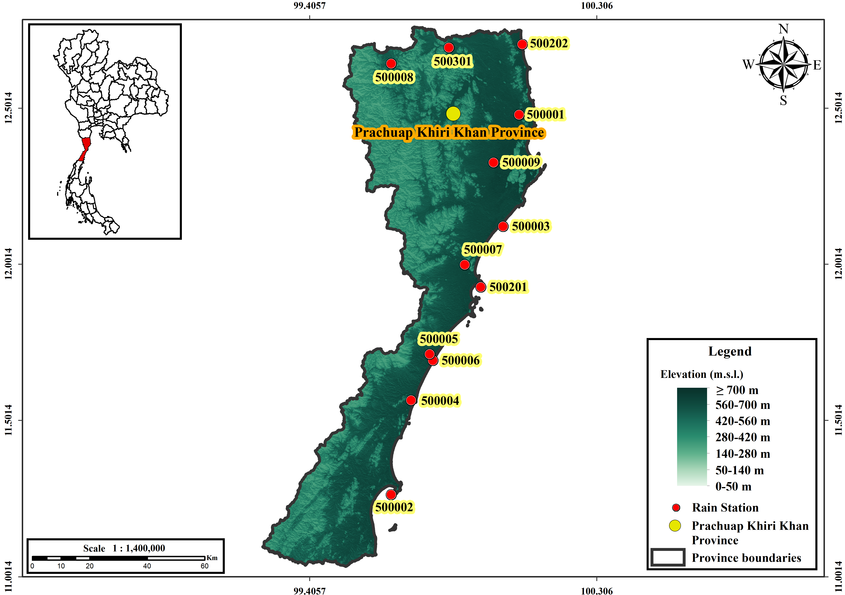
Figure 1. Location of the 12 rain gauges in Prachuap Khiri Khan Province, Thailand. Red circles mark gauge locations and labels identify the stations. Background shading represents elevation classes, and the inset shows the province's location within Thailand.

2.2 Climate models and experimental design
Seven CMIP6 models supplied daily precipitation for the gauge locations (Table 2). Ensemble-member and grid labels were verified against the archive filenames. CESM2 used r11i1p1f1; the other six models used r1i1p1f1.
A single split was used for every method: 1981-2000 for calibration and 2001-2014 for independent validation. Validation observations were not used during fitting. All comparisons were restricted to the same 12 gauges.

Model | Institution | Ensemble member | Grid label
ACCESS-ESM1-5 | CSIRO, Australia | r1i1p1f1 | gn
CanESM5 | CCCma, Canada | r1i1p1f1 | gn
CESM2 | NCAR, United States | r11i1p1f1 | gn
EC-Earth3 | EC-Earth Consortium, Europe | r1i1p1f1 | gr
FGOALS-g3 | CAS, China | r1i1p1f1 | gn
MIROC6 | MIROC, Japan | r1i1p1f1 | gn
MRI-ESM2-0 | MRI, Japan | r1i1p1f1 | gn
Table 2. The seven CMIP6 models and their configuration.
All seven models provide daily precipitation for the historical experiment (1981–2014) and for both SSP2-4.5 and SSP5-8.5. Labels were verified against the archive filenames. gn = native model grid; gr = regridded.

2.3 Bias-correction methods
QDM was applied separately to each gauge and calendar month. Observed and simulated quantile functions were estimated in the calibration period, and relative model-projected changes were preserved at each quantile [4]. MBCn began from the QDM-corrected field and applied iterative multivariate adjustment [8]. Each of 25 passes used a seeded random orthogonal rotation across the 12 station dimensions, mapped each rotated component to the corresponding rotated observations, and reversed the rotation. Final rank substitution restored the QDM values at every station, retaining QDM marginal distributions while adjusting inter-station ranks (Figure 2). Related multistation comparisons also highlight the need to evaluate correction methods beyond marginal performance [19].
All QDM mappings, rotations, and rotated-space mappings were fitted using 1981-2000 data only. The 2001-2014 observations were reserved for evaluation. A wet day was defined as precipitation of at least 1 mm. Thresholds for extreme-event diagnostics were estimated separately from each series' wet days so that these diagnostics primarily reflected dependence rather than residual intensity differences.
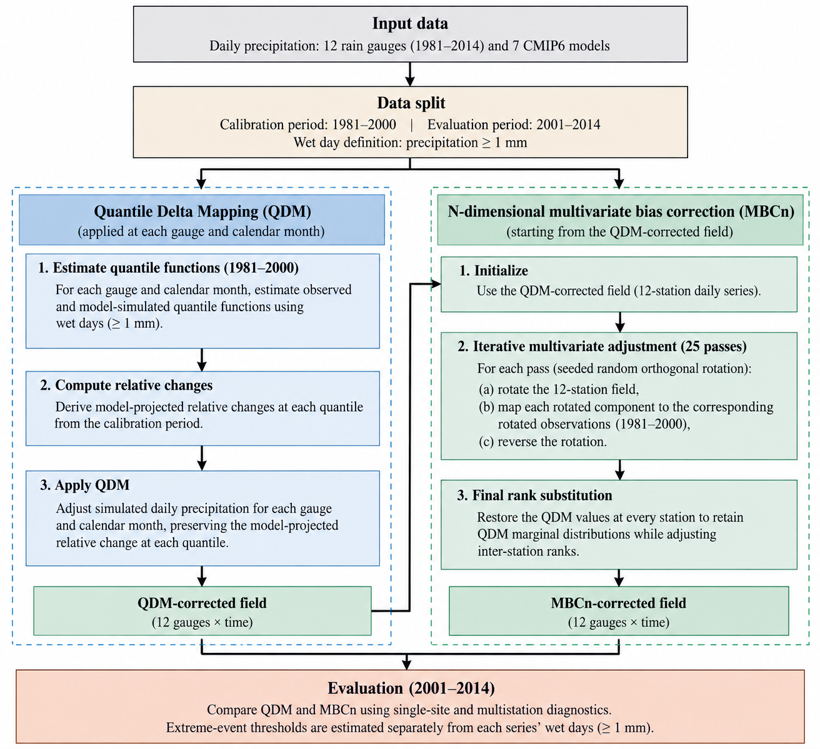
Figure 2. MBCn workflow. QDM [4] first establishes each gauge's marginal distribution; the iterative rotation, mapping, and inverse-rotation stage [8] adjusts inter-station dependence; final rank substitution restores the QDM values. All transformations are fitted using calibration data only.

2.4 Single-site diagnostics
Because free-running climate simulations are not synchronized with observed daily weather, single-site performance was assessed distributionally. Six diagnostics were computed for each of 84 gauge-model combinations: percentage bias in total precipitation, wet-day-frequency error, the ratio of simulated to observed wet-day standard deviation, Perkins skill score [20], Kolmogorov-Smirnov distance, and RMSE between matched wet-day quantiles. Day-matched criteria were not used because they would penalize timing that free-running simulations are not designed to reproduce.

2.5 Dependence diagnostics and statistical testing
Six diagnostics evaluated joint behaviour. Energy distance compared the 12-dimensional daily precipitation vectors with observations [21] using a fixed-seed subsample of at most 1,500 validation days. Three metrics measured RMSE across the 66 off-diagonal station pairs for Spearman correlation, Pearson correlation, and binary wet-day correlation. Two metrics targeted concurrent extremes: RMSE of pairwise joint exceedance above each series' 95th wet-day percentile and the Wasserstein-1 distance between distributions of daily network wet extent. Each diagnostic was computed separately for each climate model.
Seven paired model-level differences between MBCn and QDM were summarized with a one-sided exact Wilcoxon signed-rank test, the matched-pairs rank-biserial effect size, and the number of models favouring MBCn. The test describes consistency within this ensemble rather than inference to a population of climate models. Holm-Bonferroni adjustment was applied to the prespecified family of Spearman, Pearson, and wet-day-correlation endpoints; the other diagnostics were treated as exploratory.

2.6 Robustness checks
Robustness was evaluated by varying the number of MBCn passes from 0 (QDM) to 100 and repeating the default 25-pass correction with 20 random seeds. Fidelity to the model-projected signal was evaluated by comparing raw and corrected percentage changes in five wet-day quantiles for every gauge, model, pathway, and future period. This check addresses quantile changes only and does not validate the projections themselves.

3. Results and Discussion

3.1 Single-site performance is identical between the two corrections
The raw output produced rain too frequently and underestimated wet-day variability (Table 3 and Figure 3). After correction, Kolmogorov-Smirnov distance decreased from 0.221 to 0.101 and Perkins skill score increased from 0.82 to 0.91. Both corrections retained an approximately 17% dry bias in total precipitation and a wet-day-frequency bias of about -6 percentage points; this residual bias should be considered in water-balance applications.
QDM and MBCn were identical to three decimal places for every marginal score across all 84 gauge-model combinations. This confirms the expected algorithmic behaviour: final rank substitution returns the same set of daily QDM values at each gauge. The multivariate stage can therefore affect only how values are arranged jointly across the network, not their station-level distributions.

Method | PBIAS (%) | Wet-day frequency error (pp) | SD ratio (–) | PSS (–) | KS distance (–) | Quantile RMSE (mm d⁻¹)
RAW | 1.4 ± 34.7 | 10.6 ± 17.2 | 0.69 ± 0.49 | 0.82 ± 0.10 | 0.221 ± 0.104 | 7.83 ± 4.16
QDM | −17.2 ± 20.8 | −6.4 ± 12.3 | 0.98 ± 0.36 | 0.91 ± 0.05 | 0.101 ± 0.060 | 4.08 ± 3.05
MBCn | −17.2 ± 20.8 | −6.4 ± 12.3 | 0.98 ± 0.36 | 0.91 ± 0.05 | 0.101 ± 0.060 | 4.08 ± 3.05
Table 3. Single-site skill over the withheld validation period (mean ± SD, n = 84 gauge–model pairs).
pp = percentage points; PSS = Perkins skill score; KS = Kolmogorov–Smirnov; SD ratio is the corrected-to-observed ratio of the wet-day standard deviation. QDM and MBCn coincide on every score because MBCn reinstates the QDM value at each gauge.
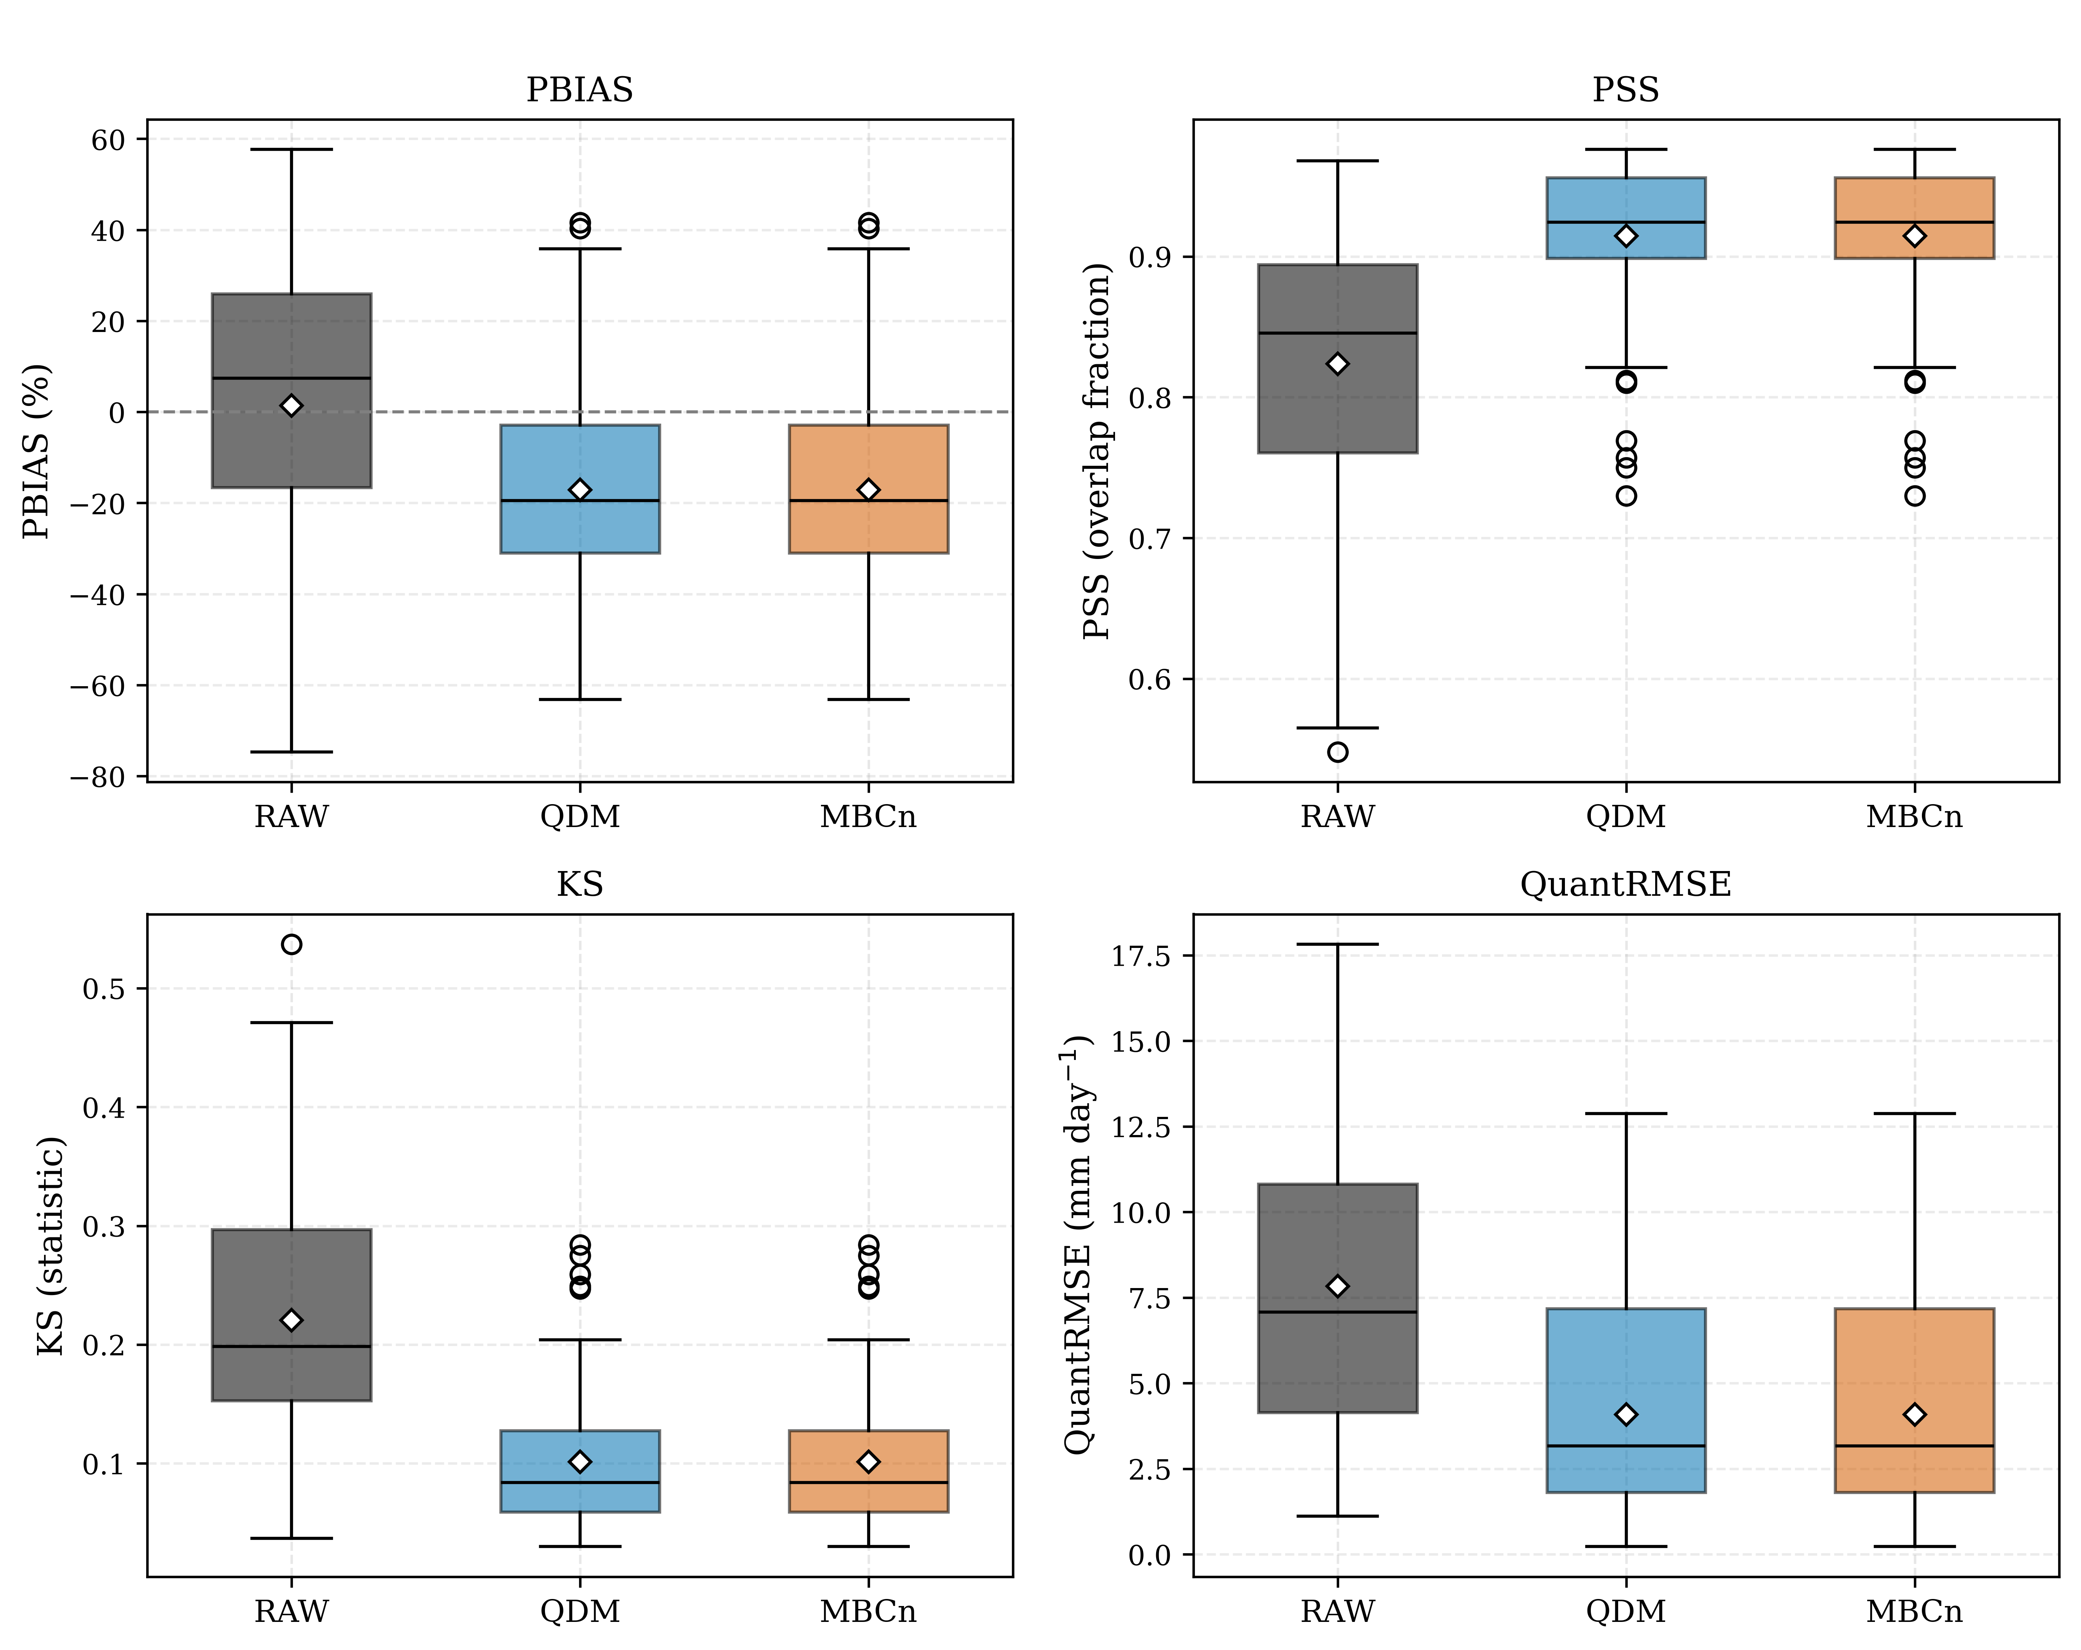
Figure 3. Single-site skill for RAW, QDM, and MBCn over the withheld validation period, one point per gauge–model pair (n = 84). Diamonds mark the mean. The QDM and MBCn distributions coincide exactly, by construction.

3.2 MBCn improves inter-station dependence consistently across models
MBCn outperformed QDM for every dependence diagnostic (Table 4). Energy distance decreased from 0.852 for QDM to 0.571 for MBCn. Spearman correlation-matrix RMSE decreased from 0.484 in raw output to 0.286 with QDM and to 0.187 with MBCn. Pearson correlation, wet-day correlation, joint 95th-percentile exceedance, and wet-extent distribution showed the same ordering.
Every model improved under MBCn for all six diagnostics (Table 5). With seven concordant non-zero paired differences, the one-sided exact Wilcoxon p-value was 0.0078, the smallest attainable value at n = 7, and the matched-pairs rank-biserial effect size was 1.00. Holm-Bonferroni-adjusted p-values for the three prespecified correlation endpoints were 0.0234. These values summarize a unanimous within-ensemble pattern; the models are not a random sample, and the six diagnostics are related views of the same dependence improvement.
The model-level results show that the ensemble mean was not driven by a small number of influential models. The seven-of-seven improvement in Table 5 occurred for energy distance, three correlation measures, joint-exceedance error, and wet-extent distance. Agreement across these related diagnostics indicates that MBCn improved several features of the joint precipitation structure rather than a single summary statistic.
Spatially, pairwise Spearman correlation declined modestly with gauge separation in the observations (Figure 4). Raw output remained near 0.96 across most distances, indicating pronounced over-coherence. QDM reduced this bias, whereas MBCn most closely followed the observed distance relationship. Some raw over-coherence is expected when gauges share or occupy adjacent coarse grid cells. The binned relationship and bootstrap bands are descriptive because the 66 gauge pairs are not independent.

Method | Energy distance | Spearman RMSE | Pearson RMSE | Wet-occurrence RMSE | Joint q95 RMSE | Wet-extent W₁
RAW | 1.283 | 0.484 | 0.488 | 0.476 | 0.0150 | 0.174
QDM | 0.852 | 0.286 | 0.374 | 0.273 | 0.0054 | 0.107
MBCn | 0.571 | 0.187 | 0.134 | 0.139 | 0.0029 | 0.079
Table 4. Dependence diagnostics against observations (seven-model mean, withheld validation period). All scores are negatively oriented, so lower is better.
Values are means of per-model scores. The energy distance is the broadest whole-distribution measure, computed on a fixed-seed random subsample of at most 1,500 days; the correlation-matrix RMSEs, the joint-exceedance RMSE and the wet-extent Wasserstein-1 distance (W₁) are structure diagnostics. Joint exceedance uses each series' own wet-day ninety-fifth percentile and wet extent the 1 mm threshold. MBCn is closest to observations on every diagnostic. All quantities are dimensionless.

Diagnostic | Models favouring MBCn | W | p | Holm-adjusted p | Effect size
Energy distance (secondary) | 7 / 7 | 28.0 | 0.0078 | – | 1.00
Spearman RMSE (primary) | 7 / 7 | 28.0 | 0.0078 | 0.0234 | 1.00
Pearson RMSE | 7 / 7 | 28.0 | 0.0078 | 0.0234 | 1.00
Wet-day co-occurrence RMSE | 7 / 7 | 28.0 | 0.0078 | 0.0234 | 1.00
Joint q95 exceedance RMSE (secondary) | 7 / 7 | 28.0 | 0.0078 | – | 1.00
Wet-extent W₁ (secondary) | 7 / 7 | 28.0 | 0.0078 | – | 1.00
Table 5. Paired comparison of MBCn against QDM across the seven models (one-sided Wilcoxon signed-rank test; Holm–Bonferroni adjustment within the correlation-endpoint family).
Every model improves under MBCn on every diagnostic, yielding the maximum matched-pairs rank-biserial effect size and the smallest p attainable at n = 7. The Holm adjustment covers the three pre-declared correlation endpoints; the remaining diagnostics are exploratory and reported unadjusted.
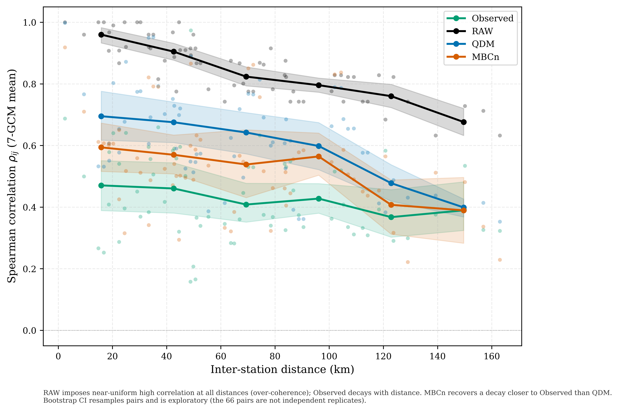
Figure 4. Inter-station Spearman correlation versus gauge separation. MBCn follows the observed distance relationship more closely than QDM, whereas raw output remains uniformly high. Bootstrap bands are exploratory because gauge pairs are not independent.

3.3 Spatial organisation of concurrent extremes
Concurrent-extreme diagnostics led to the same ordering. Figure 5 compares observed and simulated probabilities that both gauges in a pair exceeded their own 95th wet-day percentiles on the same date. Raw output was widely dispersed, QDM retained a positive bias, and MBCn lay closest to the 1:1 line without a systematic tilt.
Wet extent provides a network-scale complement to the pairwise exceedance diagnostic. The mean per-model Wasserstein-1 distance decreased from 0.107 for QDM to 0.079 for MBCn (Table 4), and all seven models improved (Table 5). MBCn therefore reproduced the daily spatial coverage of wet conditions more closely, although this metric does not identify where within the network the wet gauges occurred.
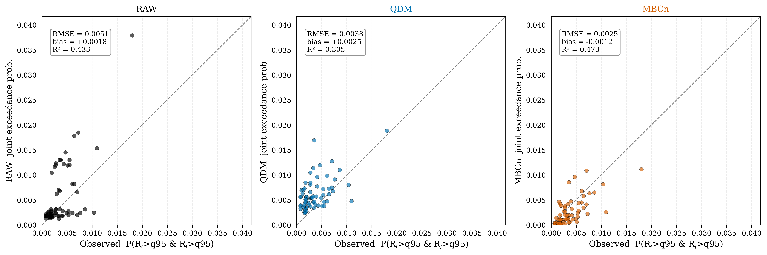
Figure 5. Pairwise probability that both gauges exceed their 95th wet-day percentile on the same day, shown as the seven-model mean against observations. MBCn lies closest to the 1:1 line and is the only method without a systematic tilt.

3.4 Numerical behaviour and fidelity to the projected change signal
Iteration and seed experiments showed that the multivariate adjustment was numerically stable. Most improvement occurred within 10-15 passes, after which the diagnostics oscillated within a narrow range; the 25-pass default therefore lay on the convergence plateau. Across 20 random seeds, correlation-based scores changed little, with a coefficient of variation of approximately 4%. Energy distance varied more because it used fixed-size random subsamples, whereas the full-sample correlation diagnostics remained stable.
Projected wet-day quantile changes were similarly preserved by both methods (Figure 6). Across all gauges, models, pathways, and future periods, mean absolute deviation from the raw change signal was 9.4 percentage points for QDM and 9.2 for MBCn; the corresponding R-squared values were 0.485 and 0.465. MBCn therefore improved dependence without a material additional loss of QDM's change-preservation property [4]. This check does not cover sequence-dependent statistics, such as wet- and dry-spell lengths, which MBCn may alter.
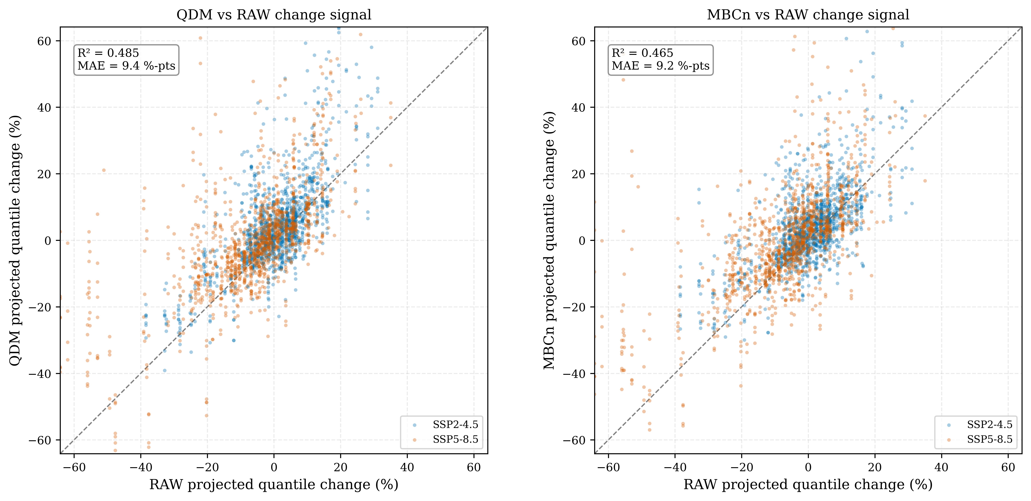
Figure 6. Raw versus corrected projected change in wet-day quantiles for every gauge, model, pathway, and future period. QDM and MBCn preserve the model-projected quantile-change signal to a similar degree.

3.5 Implications and limitations
The results support a context-specific choice rather than a universal ranking. Recent comparisons likewise show that no bias-correction method dominates every temporal and dependence property [22]; method selection should follow the structure required by the downstream application. QDM is sufficient and less computationally demanding when only single-site distributions are required, including many intensity-duration-frequency applications in Thailand [23] and basin-scale drought-risk assessments [24]. MBCn is better supported when gauges are used jointly in distributed hydrological modelling, spatial hazard mapping, or multivariate risk analysis.
More broadly, station-wise evaluation cannot distinguish methods that share marginal distributions but differ in joint behaviour. At least one dependence diagnostic should accompany conventional marginal scores whenever corrected variables or locations will be analysed together.
Four limitations bound the conclusions. One realization per model does not represent internal variability. The single coastal network may not represent inland or more strongly monsoonal settings. The stationary calibration assumes that historical dependence remains an appropriate target under future climate. Finally, the residual dry bias in both corrections limits water-balance applications. These limitations constrain generalization but do not affect the paired comparison, for which both methods used identical inputs and periods.

4. Conclusion
Across 12 coastal gauges and seven CMIP6 models, QDM and MBCn were identical for all six station-level diagnostics because MBCn restored the QDM marginal values. In contrast, MBCn improved all six dependence diagnostics for every model, reducing energy distance and correlation-structure errors while converging rapidly, remaining insensitive to random seed, and preserving projected wet-day quantile changes comparably to QDM. QDM therefore remains appropriate when only marginal fidelity is needed; MBCn is the better-supported choice when inter-station dependence is part of the scientific or hydrological question. Dependence diagnostics should become routine whenever corrected locations are used jointly. Evaluation across larger, topographically diverse networks and multi-realization ensembles is the next step for testing the generality of these findings.

Acknowledgment
The author thanks the Royal Irrigation Department for access to the daily rain-gauge records and the World Climate Research Programme and participating modelling groups for producing and distributing CMIP6 output.

Author Contributions
Surasit Punyawansiri: conceptualization, methodology, software, validation, formal analysis, investigation, resources, data curation, writing - original draft, writing - review and editing, visualization, supervision, and project administration. The author has read and approved the submitted manuscript.

Funding
This research received no external funding.

Conflicts of Interest
The author declares no conflict of interest.

Data and Code Availability
The daily rain-gauge records are available from the Royal Irrigation Department subject to its data-sharing conditions. CMIP6 output is publicly available through the Earth System Grid Federation. Analysis code and underlying numerical data for the figures are available from the corresponding author on reasonable request.

References
[1] D. Maraun, "Bias correcting climate change simulations - a critical review," Curr. Clim. Change Rep., vol. 2, no. 4, pp. 211-220, 2016, doi: 10.1007/s40641-016-0050-x.
[2] C. Teutschbein and J. Seibert, "Bias correction of regional climate model simulations for hydrological climate-change impact studies: Review and evaluation of different methods," J. Hydrol., vols. 456-457, pp. 12-29, 2012, doi: 10.1016/j.jhydrol.2012.05.052.
[3] L. Gudmundsson, J. B. Bremnes, J. E. Haugen, and T. Engen-Skaugen, "Technical Note: Downscaling RCM precipitation to the station scale using statistical transformations - a comparison of methods," Hydrol. Earth Syst. Sci., vol. 16, no. 9, pp. 3383-3390, 2012, doi: 10.5194/hess-16-3383-2012.
[4] A. J. Cannon, S. R. Sobie, and T. Q. Murdock, "Bias correction of GCM precipitation by quantile mapping: How well do methods preserve changes in quantiles and extremes?" J. Clim., vol. 28, no. 17, pp. 6938-6959, 2015, doi: 10.1175/JCLI-D-14-00754.1.
[5] E. Bevacqua et al., "Advancing research on compound weather and climate events via large ensemble model simulations," Nat. Commun., vol. 14, Art. no. 2145, 2023, doi: 10.1038/s41467-023-37847-5.
[6] M. Vrac, "Multivariate bias adjustment of high-dimensional climate simulations: The Rank Resampling for Distributions and Dependences (R2D2) bias correction," Hydrol. Earth Syst. Sci., vol. 22, no. 6, pp. 3175-3196, 2018, doi: 10.5194/hess-22-3175-2018.
[7] Y. Robin, M. Vrac, P. Naveau, and P. Yiou, "Multivariate stochastic bias corrections with optimal transport," Hydrol. Earth Syst. Sci., vol. 23, no. 2, pp. 773-786, 2019, doi: 10.5194/hess-23-773-2019.
[8] A. J. Cannon, "Multivariate quantile mapping bias correction: An N-dimensional probability density function transform for climate model simulations of multiple variables," Clim. Dyn., vol. 50, nos. 1-2, pp. 31-49, 2018, doi: 10.1007/s00382-017-3580-6.
[9] B. François, M. Vrac, A. J. Cannon, Y. Robin, and D. Allard, "Multivariate bias corrections of climate simulations: Which benefits for which losses?" Earth Syst. Dyn., vol. 11, no. 2, pp. 537-562, 2020, doi: 10.5194/esd-11-537-2020.
[10] D. Dieng et al., "Multivariate bias-correction of high-resolution regional climate change simulations for West Africa: Performance and climate change implications," J. Geophys. Res. Atmos., vol. 127, no. 8, Art. no. e2021JD034836, 2022, doi: 10.1029/2021JD034836.
[11] S. I. Seneviratne et al., "Weather and climate extreme events in a changing climate," in Climate Change 2021: The Physical Science Basis, Cambridge, U.K.: Cambridge Univ. Press, 2021, pp. 1513-1766, doi: 10.1017/9781009157896.013.
[12] S. Supharatid, J. Nafung, and T. Aribarg, "Projected changes in temperature and precipitation over mainland Southeast Asia by CMIP6 models," J. Water Clim. Change, vol. 13, no. 1, pp. 337-356, 2022, doi: 10.2166/wcc.2021.015.
[13] X. Qin and C. Dai, "Comparison of different quantile delta mapping schemes in frequency analysis of precipitation extremes over mainland Southeast Asia under climate change," J. Hydrol., vol. 606, Art. no. 127421, 2022, doi: 10.1016/j.jhydrol.2021.127421.
[14] S. Try and X. Qin, "Evaluation of future changes in climate extremes over Southeast Asia using downscaled CMIP6 GCM projections," Water, vol. 16, no. 15, Art. no. 2207, 2024, doi: 10.3390/w16152207.
[15] U. W. Humphries, M. Waqas, P. T. Hlaing, P. Dechpichai, and A. Wangwongchai, "Assessment of CMIP6 GCMs for selecting a suitable climate model for precipitation projections in Southern Thailand," Results Eng., vol. 23, Art. no. 102417, 2024, doi: 10.1016/j.rineng.2024.102417.
[16] S. Rojpratak and S. Supharatid, "Regional extreme precipitation index: Evaluations and projections from the multi-model ensemble CMIP5 over Thailand," Weather Clim. Extremes, vol. 37, Art. no. 100475, 2022, doi: 10.1016/j.wace.2022.100475.
[17] D. Khadka, M. S. Babel, M. Collins, S. Shrestha, S. G. P. Virdis, and A. S. Chen, "Projected changes in the near-future mean climate and extreme climate events in Northeast Thailand," Int. J. Climatol., vol. 42, no. 4, pp. 2470-2492, 2022, doi: 10.1002/joc.7377.
[18] D. Kuinkel, P. Promchote, K. R. Upreti, S.-Y. Wang, N. Dahal, and B. Pokharel, "Projected changes in precipitation extremes in Southern Thailand using CMIP6 models," Theor. Appl. Climatol., vol. 155, no. 9, pp. 8703-8716, 2024, doi: 10.1007/s00704-024-05150-y.
[19] Y. H. Song and E.-S. Chung, "Comparison of quantile mapping methods for daily precipitation correction and future projections under the SSP5-8.5," J. Korea Water Resour. Assoc., vol. 57, no. 12, pp. 1069-1083, 2024, doi: 10.3741/JKWRA.2024.57.12.1069.
[20] S. E. Perkins, A. J. Pitman, N. J. Holbrook, and J. McAneney, "Evaluation of the AR4 climate models' simulated daily maximum temperature, minimum temperature, and precipitation over Australia using probability density functions," J. Clim., vol. 20, no. 17, pp. 4356-4376, 2007, doi: 10.1175/JCLI4253.1.
[21] G. J. Székely and M. L. Rizzo, "Energy statistics: A class of statistics based on distances," J. Stat. Plan. Inference, vol. 143, no. 8, pp. 1249-1272, 2013, doi: 10.1016/j.jspi.2013.03.018.
[22] S. Sharma, A. S. Raghuvanshi, and A. Agarwal, "Evaluating the performance of uni- and multivariate bias correction techniques: Challenges in preserving temporal and dependence structures," Water Resour. Res., vol. 62, no. 2, Art. no. e2025WR041526, 2026, doi: 10.1029/2025WR041526.
[23] K. Tedprasith and W. Lohpaisankrit, "Development of intensity-duration-frequency relationships in Khon Kaen City, Thailand under changing climate using GCMs and a simple scaling method," J. Water Clim. Change, vol. 15, no. 3, pp. 1204-1217, 2024, doi: 10.2166/wcc.2024.533.
[24] J. Srinate and R. Hormwichian, "Modeling future water deficit trends under varying climate change projections in Huai-SamMor Basin, Thailand," Engineering Access, vol. 12, no. 1, pp. 51–62, 2026.

